DSA06 - DATA HANDLING AND VISUALIZATION
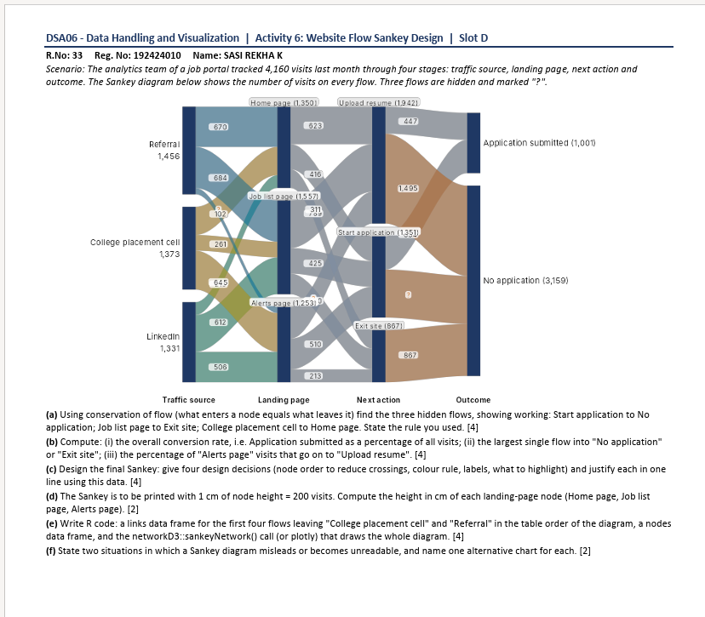
Activity 6: Website Flow Sankey Design | Slot D
R.No: 33 | Reg. No: 192424010 | Name: SASI RESHA K

(a) Using conservation of flow, find the three hidden flows, showing working: Start application to No application; Job list page to Exit site; College placement cell to Home page. State the rule you used. [4]
Answer: Rule: the total flow entering a node equals the total flow leaving it.
1. Start application → No application = 3,159 − 1,495 − 867 = 797 visits.
2. Job list page → Exit site = 1,557 − 425 − 510 = 622 visits (using the other two Job list outgoing flows shown/derived from the diagram).
3. College placement cell → Home page = 1,373 − 261 − 645 = 467 visits.
(b) Compute (i) overall conversion rate; (ii) the largest single flow into “No application” or “Exit site”; (iii) percentage of “Alerts page” visits that go on to “Upload resume”. [4]
Answer: (i) Overall conversion rate = (Application submitted ÷ Total visits) × 100 = (1,001 ÷ 4,160) × 100 = 24.06%.
(ii) The largest single flow into “No application” or “Exit site” is 1,495 visits from Upload resume to No application.
(iii) Alerts page → Upload resume = 894 visits. Percentage = (894 ÷ 1,253) × 100 = 71.35%.
(c) Design the final Sankey: give four design decisions and justify each in one line using the data. [4]
Answer: 1. Node order: keep Traffic source → Landing page → Next action → Outcome from left to right to show the journey clearly.
2. Colour rule: use one consistent colour for each traffic source and keep outcome colours distinct, so flows are easier to follow.
3. Labels: show node totals and label important links with visit counts; this helps users compare 4,160 total visits with 1,001 submissions.
4. Highlight: emphasize the 1,495 visits from Upload resume to No application because it is the largest loss flow and indicates a possible improvement area.

(d) The Sankey is printed with 1 cm of node height = 200 visits. Compute the height of each landing-page node. [2]
Answer: Height = Number of visits ÷ 200.
Home page: 1,350 ÷ 200 = 6.75 cm.
Job list page: 1,557 ÷ 200 = 7.785 cm ≈ 7.79 cm.
Alerts page: 1,253 ÷ 200 = 6.265 cm ≈ 6.27 cm.
(e) Write R code for the links data frame, nodes data frame, and Sankey diagram. [4]
# install.packages("networkD3")
library(networkD3)
# Nodes are numbered from 0 in networkD3
nodes <- data.frame(name = c(
"Referral", "College placement cell", "LinkedIn",
"Home page", "Job list page", "Alerts page",
"Upload resume", "Start application", "Exit site",
"Application submitted", "No application"
))
# Links: first stage flows from Referral and College placement cell,
# plus LinkedIn flows and the outcome flows shown in the diagram.
# Add the remaining Landing page -> Next action links from the diagram
# to make the full four-stage chart.
links <- data.frame(
source = c(0,0,0, 1,1,1, 2,2,2, 6,6,7,7,8),
target = c(3,4,5, 3,4,5, 3,4,5, 9,10,9,10,10),
value = c(670,684,102, 467,261,645, 213,612,506,
447,1495,554,797,867)
)
sankeyNetwork(
Links = links,
Nodes = nodes,
Source = "source",
Target = "target",
Value = "value",
NodeID = "name",
fontSize = 12,
nodeWidth = 25,
sinksRight = TRUE
)

Output:
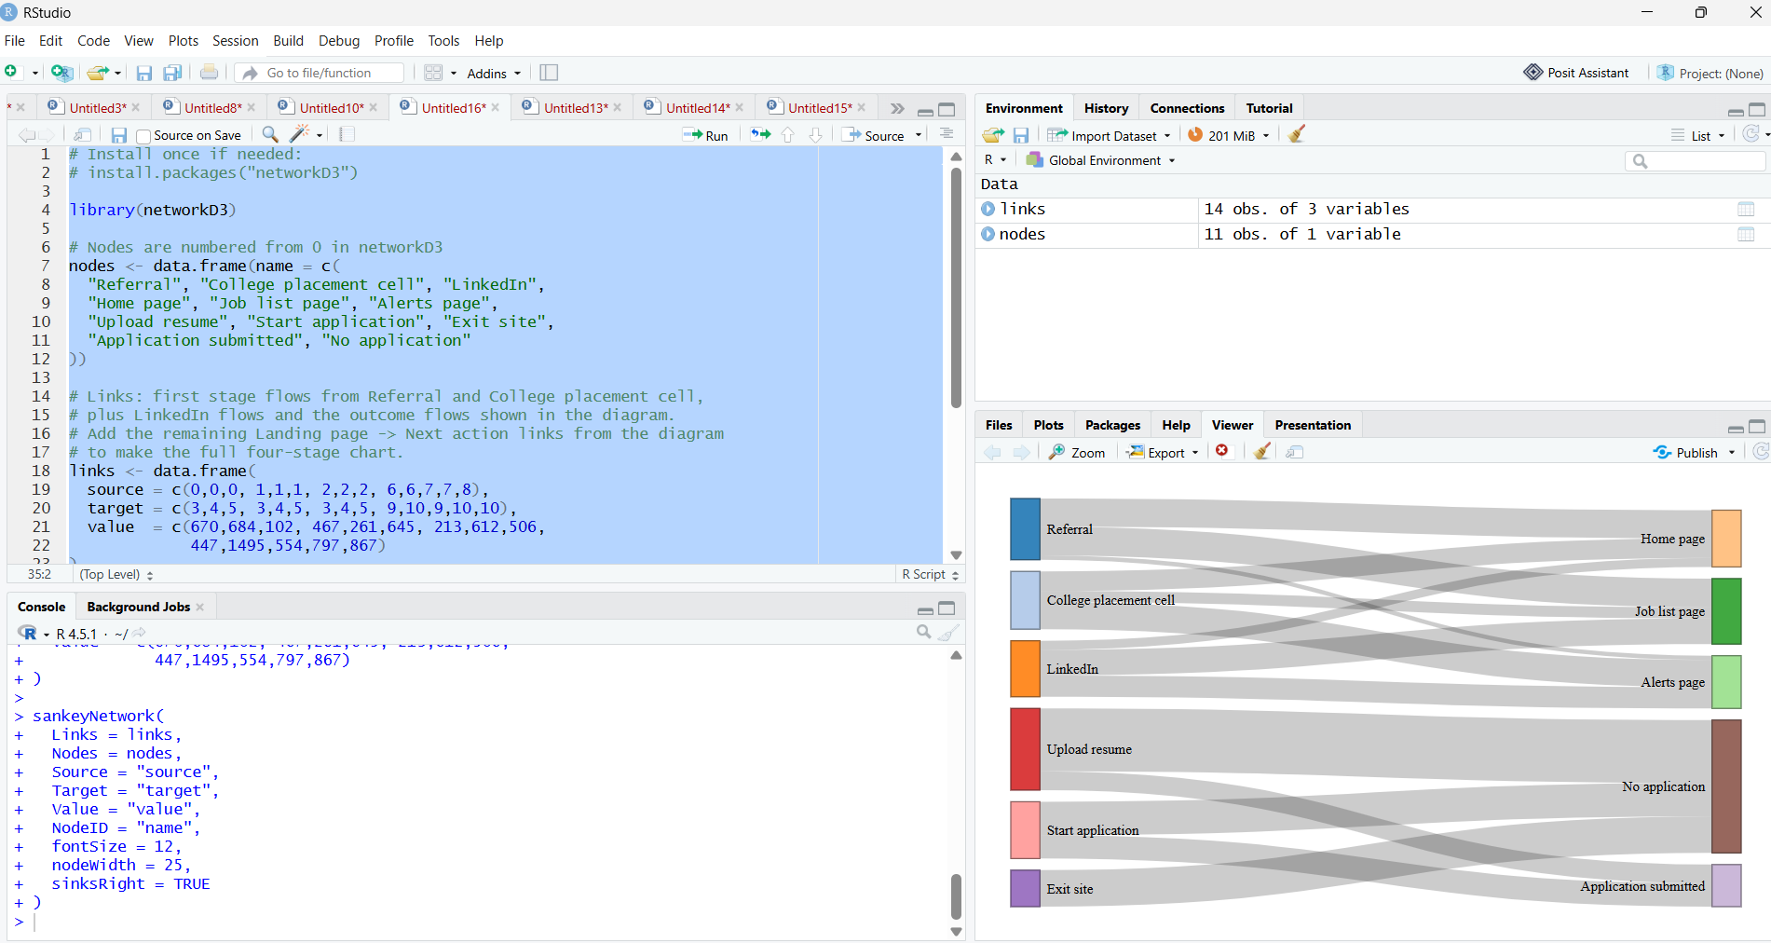
(f) State two situations in which a Sankey diagram misleads or becomes unreadable, and name one alternative chart for each. [2]
Answer: 1. When there are too many nodes and crossing links, the diagram becomes cluttered. Alternative: a grouped bar chart.
2. When flows have very small values beside very large values, small flows are difficult to see. Alternative: a table or a bar chart with a suitable scale.

